DISNEY KINDERGARTEN AND PRIMARY SCHOOL
P.2 MATHEMATICS LESSON NOTES FOR TERM II 2020
THEME: OUR ENVIROMENT
SUB THEME: Operation on whole numbers
Sub-theme: DIVISION
Lesson 1
Practical work.
Get different materials like;
bottle tops, straws, rulers, pencils, books, etc. to teach division.
MENTAL WORK
2+4=
2-2=
Listen and write
Star rectangle
Circle triangle
Cylinder oval

Examples
- Share equally
14÷7= 12÷6= 9÷3=
Exercise
Divide these numbers correctly.
20÷4= 16÷2= 10÷5= 18÷2=
30÷10= 15÷3= 6÷3=
LESSON TWO
Mental work
Listen and draw.
Kite square oval cone
Division of numbers using short method.
Examples

2 12 3 12
2 10
EXERCISE
Work out these numbers.

4 8 2 18 2 22 3 30

LESSON 3
Mental work
Expand
35= 149 = 807= 987=
Word problem involving division
Examples

1. There are 8 sweets for 2 children
How many sweets will each get?
0 0 each child will
^ ^ get 4 sweets
, ,
, ,
, ,
, ,
4 4
2. Share 10 sweets equally among 5 girls. How many sweets does each girl get?
Exercise
1. Share 15 tomatoes equally among 5 girls, how many does each girl get?
2. Share 30 oranges equally among 10 boys, how many oranges does each boy get?
3. Share 14 bags equally among two children, how many bags does each one get?
4. A mother had 16 bananas, she shared them between her two children.
How many bananas do each child get?
5. Two girls shared 6 apples. How many bananas did each girl get?
THEME: TRANSPORT IN OUR COMMUNITY
SUB-THEME: TYPE OF TRANSPORT
Lesson 4
Mental work
1. What is 10 and 4 less?
2. What is the product of 3 and 4?
3. How many legs do 3 girls have?
4. A bird has 2 wings. How many wings do 3 birds have?
5. A bicycle has 2 wheels. How many wheels do three bicycles have?
Division of numbers:
EXAMPLES
1. Completing division table.
÷ | 2 | 3
6 | 3 | 2
12 | 6 | 4

Divide each number by 2 and 3

Exercise
Complete this table below.
- Completing division table.
÷ | 2 | 5
10
20

Divide each number by 2 and 5

3. Completing division table.
÷ | 2 | 3
6 | 3 | 2
12 | 6 | 4

Divide each number by 2 and 3

MEASURES
Lesson 5
Measuring length and width using nonstandard units.
Practical activity.
Measure the length and width of the following:
Items | Length(no of rulers) | width
classroom
Your table
whiteboard
Sitting room
bedroom
Measure and compare height, width, breadth, and body weight using
Nonstandard measures.
Work out:
What number has been expanded?
100+20+3= 800+0+9= 200+80+4= 30+9=
Height
Compare using taller or shorter (Learning aids)
Examples
Compare the following
A table 10 metres

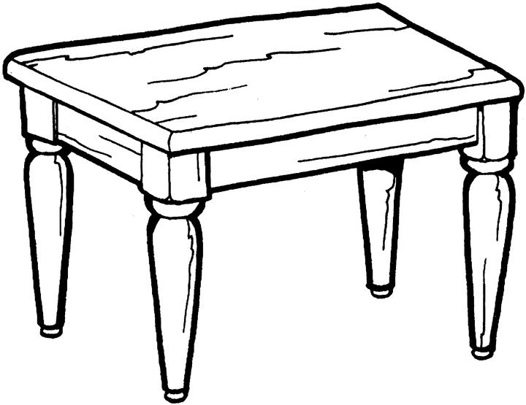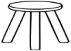
A stool
5 metres
A table is taller than a stool.
A stool is shorter than a table.
A table is 10 metres.
Find the total metres the two objects measure.
1 0 metres
+ 5 metres
1 5 metres

Exercise
Compare these objects using taller or shorter
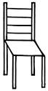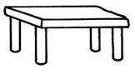
5metres
3 metres
A _____________________ taller than a table.
A table is ______________than a chair.

Find the total height of the two objects.
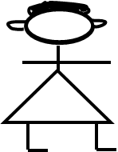

15 metres
20 metres

Jane Sarah
Who is 20 metres ____________________________
Find the height of Jane and Sarah.

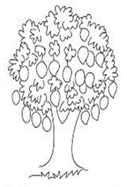
30 M
Tree C
Tree D
20 M

Which tree is taller? _________________________________
Tree ________________ is taller.
Find the total metres of tree C and D.
Lesson 6
Mental work
Write in figures

- a half ________________
- a quarter ______________
- a ninth _____________
- Twentieth ______________
- Fifth ________________

Comparing the length using longer than or shorter than
Examples
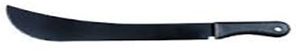
w x

panga w is shorter than panga x
panga x is longer than panga w
Exercise
Compare the length using longer than or shorter than
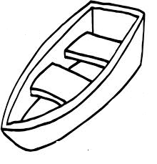
T Y

Boat Y is ________________ than boat T.
Boat T is _______________ than boat Y.

Sugarcane X
Sugarcane Y
RULER X

Sugarcane X is ________ than Sugarcane Y.
Sugarcane Y is ________ than Sugarcane X
Lesson 7
Listen and write
January, February, March, April, May, June
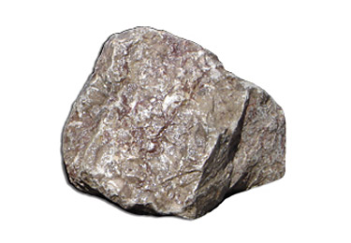
Stone B
40 kg
Comparing weight
Example
Stone A
10 Kg

- Which stone is heavier? ___________________
- Which stone is lighter? ____________________
- Find the weight of stone A and B.
EXERCISE
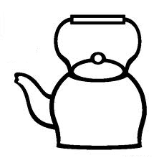
Compare the weight using lighter than or heavier than
Kettle

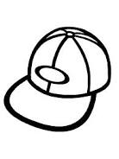
Hat

4kgs 1kg
a) Which object is lighter? ___________________________
4 kg
b) ____________ is heavier than a hat.
c) What is their total weight?
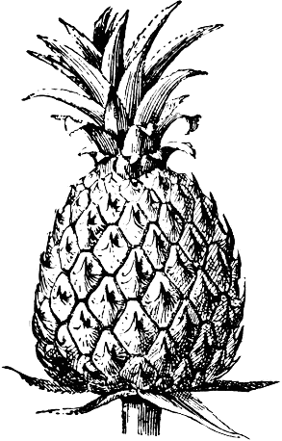
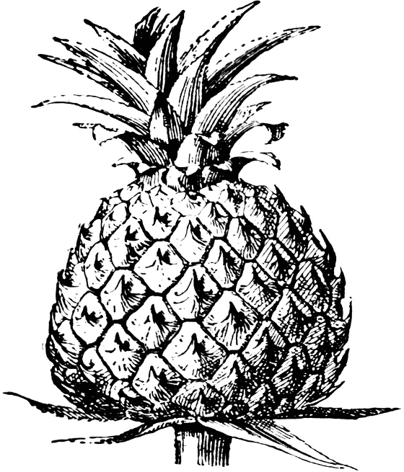
Pineapple A A
Pineapple B
15 kg
20 kg B

a) Pineapple __________ is heavier than pineapple _______
b) Pineapple __________ weighs 15kg.
c) Add the total weight of the two pineapples.
Lesson 8
Measuring capacity using nonstandard units.
Compare using more or less
Listen and write in words
99,
44,
103,
18

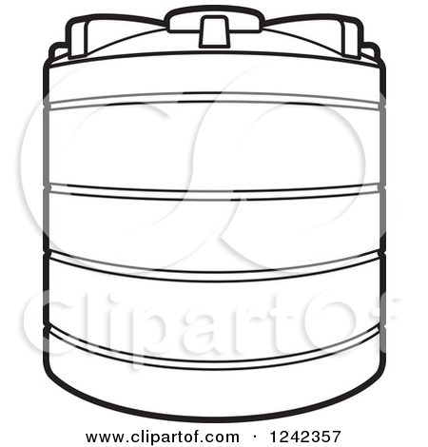
Examples
Tank B
– 100 litres
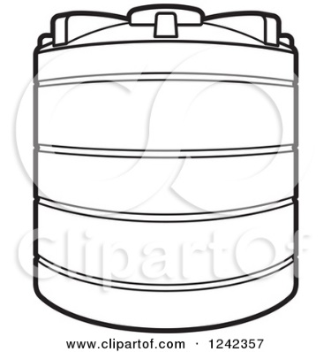
Tank A – 100 litres

Which tank holds more water? ___________________________
How many litres does tank B hold? _______________________
Add the total capacity of tank A and B.
Exercise.
Compare the capacity using more or less.
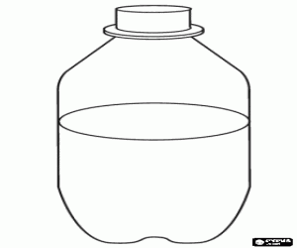
Y
8L
Z
5L

- Which bottle holds more water?
- Bottle Z holds ______ water than bottle ____________
- Find the total capacity the two bottles hold.
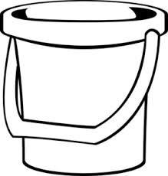
Bucket F
10 L
Bucket E
8L

Use more or less
Bucket E holds ______________ water than bucket F
Bucket F holds ___________________water than bucket E

NUMBER FACTS AND SEQUENCES.
Lesson 9
MENTAL WORK
- A cat has four legs. How many legs do 2 cats have?
- Draw the following shapes
- Square
- Kite
- Cone
- Cylinder
FIND THE MISSING NUMBERS.
Examples
1) 2, 4, 6, ____, 8, 10, ____ (keep adding 2 to each number, then write the answer)
2) 10, 12, ____, 16, _____, _______
Exercise
Find the missing numbers
- 2, 4, ______, 8, 10, ______, _______, 16

- 12, 14, ______, _______, 20, ______, 24

- 20, 22, _____, _____, ____

- 10, 12, ______, _____, 18, _______

- 26, _____, 30, ________
Lesson 10
Work out
1. 10÷2
2. 6+4=
3. 9- 6=
4. What is the sum of 6 and 4?
5. What is the product of 2 and 4?
Count in threes
Examples
Count in threes
3, 6, __, 12__, keep adding 3

3, 6, 9, ____, 15, ____

3, 6, ___, ____, 15, _____

Exercise
Find the missing numbers
- 3, 6, ___, 12, __ keep adding 3

- 3, 6, ___, ____, 15

- 3, __9, ____, 15

- 3, 6, ___, ____, 15,_____

- 3, __9, ____,
Finding the missing numbers
Examples
Counting in fives
5, 10, ____, ____, 25 keep adding 5

20, __, 30, _____, 40, _____
Exercise
Find the missing numbers

- 5, 10, 15, _____, ______, _______

- 30, 35, 40, _____, _____, ______,

- 80, ____90, _____, ________

- 60, ______, 70, _______, ________

